  SPhere Style Boutique  Fashion Retail Outfit Management System | 7/29/2026  Tejal Kanti -ST10513267  Web Development - WEDE

Table of Contents
1. Organization Overview 3
Name of Organization: 3
Mission Statement of the Organization: 3
Vision of the Organization: 3
Target Audience of the Organization: 3
History of Organization: 4
2. Website Goals and Objectives 5
Website Goals: 5
Key Performance Indicators (KPIs): 6
3. Proposed Website Features and Functionalities 7
The Key Features with its functionalities: 8
4. Design and User Experience 10
The Design Aesthetic and Branding 10
The Color Scheme 10
The Typography 11
Layout and Design 11
User Experience (UX) Considerations 12
Low-Fidelity Wireframes 13
5. Technical Requirements 16
Programming Languages and Frameworks 16
Hosting and Domain Requirements 17
File and Folder Structure 17
6. Timeline and Milestones 18
7. Budget 19
8. Site Map 20
9. Logo Design 21
References 22

Table of Figures

Table 1: KPI's Target Table (Help, 2026) (Jr, et al., 2022) 6
Table 2: The main pages that the website will include 7
Table 3: The Color Palette of the Website 10
Table 4: The type of fonts that will be used in the website 11
Table 5: The Programming Languages and their purpose 16
Table 6: Hosting and Domain Requirements (Saoula, et al., 2023) 17
Table 7: Timeline of creating the website 18
Table 8: Budget Estimation for the Website 19

Figure 1: Homepage Wireframe 13
Figure 2: About Us Page Wireframe 14
Figure 3: Products Page Wireframe 14
Figure 4: Enquiry Page Wireframe 15
Figure 5: Contact Page Wireframe 15
Figure 6: File Structure 17
Figure 7: Site Map 20
Figure 8: Logo Design 21

Organization Overview

Name of Organization:
Sphere Style Boutique

Mission Statement of the Organization:
To deliver stylish, coordinated fashion experiences that empower customers to look and feel their best, through expertly curated outfits and personalized styling services.

Vision of the Organization:
To become a trusted fashion destination that inspires confidence and self-expression through accessible, trend-conscious style.

Target Audience of the Organization:
Sphere Style Boutique's website is designed to be showcased and used by fashion-conscious shoppers mainly aged between 14 to 45 who are interested in stylish outfit ideas and trend-forward clothing. In-store and online sales staff who use the system to recommend complete outfit combinations and match accessories to customers. Returning customers seeking seasonal collections, promotions, and new arrivals from the boutique.

History of Organization:
Sphere Style Boutique was established as a fashion boutique in the retail organization with a focus on organization, trend-forward clothing and professional styling services. This boutique was created to bridge the gap between high-street fashion and personalized styling experiences, offering customers a carefully selected range of clothing items, accessories, and seasonal collections.
Sphere Style Boutique operates as a clothing boutique and clothes retailer, using a Retail Outfit and Style Management System to support its sales and merchandising processes. Rather than functioning as a personal wardrobe tool, this system is designed to serve the retailer's needs, helping staff create outfit combinations from items available for sale, organize seasonal and promotional looks, and deliver tailored styling recommendations to customers in-store and online.
The proposed website serves as the digital extension of Sphere Style Boutique, supporting outfit planning, product showcasing, merchandising, and customer engagement through a modern, fully responsive online platform.

Website Goals and Objectives

Website Goals:
The Sphere Style Boutique website is designed to achieve the following specific goals:

1. Increase Online Engagement: Drive traffic to the website and encourage users to explore outfit collections, product catalogues, and seasonal lookbooks.

2. Showcase Outfit Collections: Display curated outfit combinations built from the store's available clothing items, organized by season, occasion, and style.

3. Promote Products: Highlight new arrivals, featured promotions such as Women’s Day and holiday collections, and seasonal sales campaigns to encourage purchases.

4. Support Staff Recommendations: Provide sales staff with a digital tool to quickly suggest complete and coordinated outfits for customers based on occasion, style, season, and color preference.

5. Improve Customer Enquiries: Offer a structured and accessible enquiry form for customers to request styling advice, product availability, or general information.

6. Establish an Online Presence: As Sphere Style has no existing website, this project will create a professional, responsive digital presence from the ground up. (Nottingham, et al., 2002) (Saoula, et al., 2023)

Key Performance Indicators (KPIs):

The following KPIs will be used to measure the success of the website:
KPI | Description | Target
Monthly Visitors | Number of unique users visiting the site per month | +500 within 3 months
Enquiry Submissions | Number of completed enquiry forms submitted | +20 per month
Outfit Views | Number of views on outfit collection and product pages | +300 per month
Average Session Duration | Time spent by users on the website per visit | +2 minutes
Conversion Rate | Percentage of visitors who submit an enquiry or click a product | +5%
Leave Rate | Percentage of users who leave after viewing only one page | Below 50%
Table 1: KPI's Target Table (Help, 2026) (Jr, et al., 2022)

Proposed Website Features and Functionalities
The Sphere Style Boutique website will include the following pages with its functional features:
Page | File Name | Description
Homepage | index.html | Hero image, brand introduction, call-to-action buttons, featured outfit collections, and navigation menu
About Us | about.html | Organization history, mission and vision statements, and team introduction
Products | products.html | Full product catalogue with categories, seasonal collections, and outfit combinations
My Cart ( Your Purchases) | mycart.html | Full list of items customer has selected to buy based on their liking.
Enquiry | enquiry.html | Customer enquiry form for styling advice, product queries, sizing, and appointment requests
Contact | contact.html | Contact details, store location, embedded map, and contact form
Table 2: The main pages that the website will include

The Key Features with its functionalities:
- Outfit Builder (Deldjoo, et al., 2023)
  - Display curated outfit combinations created from items sold in-store.
  - Organised by seasons: Summer, Winter, Autumn, and Spring collections.
  - Filterable by occasion: Office Wear, Casual Wear, and Formal Wear.
  - Enables staff to reference and present outfit suggestions to customers.
  - Allows enquiries from customers about sizing.

- Product Catalogue
  - Display individual clothing items with the following details:
    - Brand
    - Category (tops, bottoms, shoes, accessories)
    - Size
    - Color
    - Price
    - Optional inventory status indicators show in stock, low stock, or out of stock.

- Outfit Library and Seasonal Collections
  - Summer Collection
  - Winter Collection
  - Office Wear
  - Casual Wear
  - Formal Wear

- Customer Recommendations (Deldjoo, et al., 2023)
  - Staff can use the website to suggest complete outfits based on:
    - Occasion
    - Style preference
    - Season
    - Color preference

- Promotions Section
  - Featured outfit highlights for:
    - Women’s Day campaigns
    - New arrivals
    - Holiday collections
    - Store window displays
- Responsive Navigation
  - A consistent navigation menu accessible across all pages.
  - Mobile-first, hamburger-style menu for smaller screen sizes.

- Contact and Enquiry Forms
  - Enquiry form for products, size and styling requests.
  - Contact form with fields for name, email, subject, and message.
  - Multiple store locations displayed with embedded maps.

Design and User Experience

The Design Aesthetic and Branding

The Sphere Style Boutique website will reflect a modern, elegant, and fashion-forward aesthetic that aligns with the boutique's brand identity. The design will prioritize clarity, visual appeal and an ease of use across all devices. (Mondol, et al., 2021)

The Color Scheme
Color | Hex Code | Usage
Black | #000000 | Primary text, navigation bar, footer
White | #FFFFFF | Page backgrounds, card backgrounds
Beige / Cream | #F5F0E8 | Section backgrounds, soft contrast areas
Accent Gold | #C9A84C | Buttons, highlights, hover states, heading accents
Blue | #90CAF9 | Seasonal items in Summer
Red/ Orange | #DD4A48 / #E25E3E | Seasonal items in Autumn
Green | #A1CB35 | Seasonal items in Spring
White / Grey | #E8E2DB | Seasonal items in Winter
Table 3: The Color Palette of the Website
The combination of black, white, and beige creates a clean, sophisticated look, while the gold accent adds a premium, boutique quality that reinforces the Sphere Style brand. While the blue, green, red and grey follows the seasonal change across the items. (Campbell, et al., 2024) (Web Content Accessibility Guidelines, 2025)

The Typography
Element | Font | Style
Primary Headings (H1) | Poppins | Bold
Secondary Headings (H2, H3) | Poppins | Semi-Bold
Body Text | Open Sans | Regular
Navigation Links | Poppins | Medium
Buttons / CTAs | Poppins | Bold
Captions / Labels | Open Sans | Light Italic
Table 4: The type of fonts that will be used in the website

Both fonts will be sourced from Google Fonts. The hierarchy establishes a clear visual distinction between headings, body content, and interactive elements.

Layout and Design

The website will follow a modern card-based responsive layout, designed using a mobile-first approach. (Nottingham, et al., 2002) (Weichbroth, 2020)
Key design principles include:
- Grid-based structure for product and outfit display sections.
- Hero sections on the homepage with full-width imagery and overlaid text.
- Card components for products, outfit collections, and promotions.
- Sticky navigation bar for ease of access across all pages.
- White space is used generously to create a premium, uncluttered feel.
- Consistent section layouts across all pages for visual coherence.

User Experience (UX) Considerations

- Navigation:
  - Simple, intuitive top navigation bar with clearly labelled links. Mobile navigation will use a collapsible hamburger menu.

- Accessibility:
  - Accessible color contrast ratios, descriptive alt text for all images, and keyboard-navigable elements. (Droutsas, et al., 2024) (Campbell, et al., 2024)

- Mobile-First Design:
  - All layouts are designed for mobile screens first, then scaled up for tablet and desktop.

- Call-to-Action Buttons:
  - Prominent call-to-action buttons such as Shop Now, View Collections, and Enquire Today are placed strategically on each page.

- Loading Performance:
  - Optimized images and minimal use of external scripts to ensure fast page loading. (Xilogianni, et al., 2022)

- Consistent Branding:
  - Uniform use of the color scheme, typography, and visual style across all pages. (Saoula, et al., 2023) (Weichbroth, 2020)

Low-Fidelity Wireframes

The following low-fidelity wireframes outline the layout and information hierarchy for each key page:

The colour palette combination of black, white, and beige creates a clean, sophisticated look, while the gold accent adds a premium, boutique quality that reinforces the Sphere Style brand. While the blue, green, red and grey follows the seasonal change across the items.

Homepage (index.html)
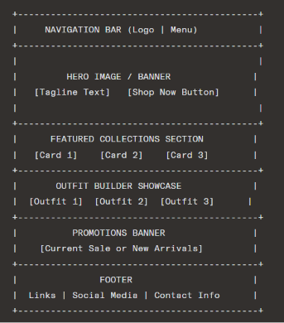
Figure 1: Homepage Wireframe

About Us (about.html)
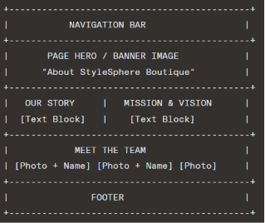
Figure 2: About Us Page Wireframe

Products (products.html)
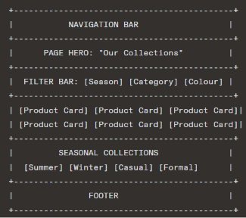
Figure 3: Products Page Wireframe

Enquiry (enquiry.html)
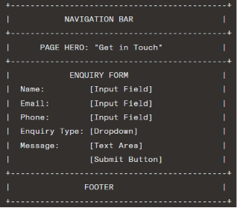
Figure 4: Enquiry Page Wireframe

Contact (contact.html)
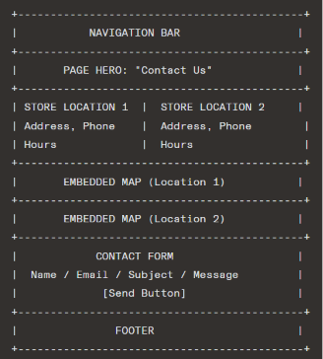
Figure 5: Contact Page Wireframe

Technical Requirements

Programming Languages and Frameworks

Technology | Purpose
HTML5 | Page structure and semantic markup for all web pages
CSS3 | Styling, layout, animations, and responsive design
JavaScript (Vanilla) | Interactive features including navigation, outfit filters, and form validation
Local Storage / JSON | Client-side data persistence for outfit collections and product details
Google Fonts | Web typography — Poppins and Open Sans
Font Awesome / SVG Icons | Iconography for navigation, social media links, and UI elements
Table 5: The Programming Languages and their purpose

Hosting and Domain Requirements

Requirement | Details
Hosting Type | Shared web hosting
Recommended Hosting Provider | Afrihost / Xneelo (South African-based hosting)
Domain Name | www.spherestyle.com
Domain Extension | .co.za (South African domain, appropriate for local boutique)
SSL Certificate | Required — to ensure secure HTTPS connection
Storage Required | Minimum 2 GB for images, files, and HTML/CSS/JS assets
Bandwidth | Unmetered or minimum 10 GB/month
Table 6: Hosting and Domain Requirements (Saoula, et al., 2023)

File and Folder Structure

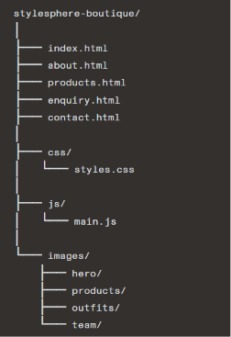
Figure 6: File Structure

Timeline and Milestones

The following project timeline outlines the key milestones for the development of the Sphere Style Boutique website, aligned with the subject's submission schedule: (Gómez, et al., 2014)

Week | Milestone | Deliverables
Week 1 | Project Proposal | Completed and submitted Website Project Proposal document
Week 2 | Content Research and Sitemap | Researched content gathered, sitemap created, file structure established
Week 3 | HTML Pages | All 5 HTML pages created with basic structure and content integration
Week 4 | CSS Styling | Full stylesheet applied — layout, color scheme, typography, responsive design
Week 5 | JavaScript Functionality | Navigation, form validation, outfit filters, and interactive elements implemented
Week 6 | Testing and Final Submission | Cross-browser testing, debugging, final review, and submission
Table 7: Timeline of creating the website

Budget

The following budget estimate is based on realistic market research for website development, hosting, and maintenance costs within the South African context for a small boutique retail business:

Item | Estimated Cost | Frequency
Website Design and Development | R 16 500.00 | Once-off
Shared Web Hosting (Xneelo/Afrihost) | R 2 500.00 | Per year + 10 % annual increase
Domain Registration (.co.za) | R 150.00 | Per year + 10 % annual increase Per year
SSL Certificate | R 500.00 | Per year + 10 % annual increase
Website Maintenance and Updates | R 5 400.00 | Per year + 10 % annual increase
Image Licensing / Stock Photography | R 800.00 | Per year + 10 % annual increase
Total Initial Cost | R 25 850.00 | N/A
Total Annual Running Cost | R 7 250.00 | Per year
Table 8: Budget Estimation for the Website

Site Map

Figure 7: Site Map

Logo Design

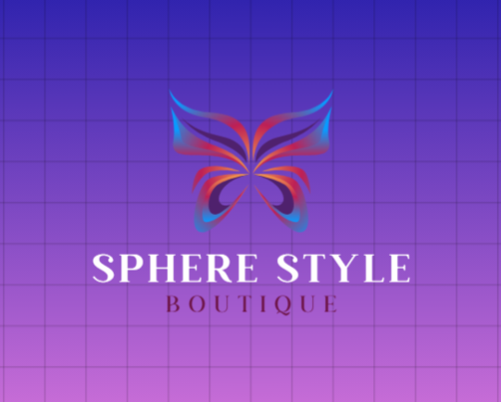
Figure 8: Logo Design

References
Campbell, A. et al., 2024. Web Content Accessibility Guidelines (WCAG) 2.2. [Online]
Available at: https://www.w3.org/TR/wcag/
[Accessed 2 August 2026].
Deldjoo, Y. et al., 2023. A Review of Modern Fashion Recommender Systems | ACM Computing Surveys. [Online]
Available at: https://dl.acm.org/doi/10.1145/3624733
[Accessed 2 August 2026].
Droutsas, N., Spyridonis, F., Daylamni-Zad, D. & Ghinea, G., 2024. Web accessibility barriers and their cross-disability impact in eSystems: A scoping review - ScienceDirect. [Online]
Available at: https://www.sciencedirect.com/science/article/pii/S0920548924000928?via%3Dihub
[Accessed 2 August 2026].
Fonts, G., 2024. Open Sans font family. [Online]
Available at: https://fonts.google.com/specimen/Open+Sans?query=open+sans
[Accessed 30 July 2026].
Fonts, G., 2024. Poppins font family. [Online]
Available at: https://fonts.google.com/specimen/Poppins
[Accessed 30 July 2026].
Gómez, R. Y., Caballero, D. C. & Sevillano, J.-L., 2014. Heuristic Evaluation on Mobile Interfaces: A New Checklist - Yáñez Gómez - 2014 - The Scientific World Journal - Wiley Online Library. [Online]
Available at: https://onlinelibrary.wiley.com/doi/10.1155/2014/434326
[Accessed 2 August 2026].
Help, G. A., 2026. [GA4] Engagement rate and bounce rate - Analytics Help. [Online]
Available at: https://support.google.com/analytics/answer/12195621?hl=en
[Accessed 2 August 2026].
Jr, E. L. F. et al., 2022. Journal of Medical Internet Research - Methodological Guidelines for Systematic Assessments of Health Care Websites Using Web Analytics: Tutorial. [Online]
Available at: https://www.jmir.org/2022/4/e28291
[Accessed 2 August 2026].
Mondol, E. P., Salman, N. A., Rahid, A. O. & Karim, A. M., 2021. HRMARS - The Effects of Visual Merchandising on Consumer’s Willingness to Purchase in the Fashion Retail Stores. [Online]
Available at: https://hrmars.com/IJARBSS/article/view/10469/The-Effects-of-Visual-Merchandising-on-Consumers-Willingness-to-Purchase-in-the-Fashion-Retail-Stores
[Accessed 2 August 2026].
Network, M. D., 2024. CSS: Cascading Style Sheets | MDN. [Online]
Available at: https://developer.mozilla.org/en-US/docs/Web/CSS
[Accessed 30 July 2026].
Network, M. D., 2024. HTML elements reference - HTML | MDN. [Online]
Available at: https://developer.mozilla.org/en-US/docs/Web/HTML/Reference/Elements
[Accessed 30 July 2026].
Nottingham, L., Shin, Y. B. & Shim, J. P., 2002. "Retailer Web Site Influence On Customer Shopping: Exploratory Study on" by J.P. Shim, Yong B. Shin et al.. [Online]
Available at: https://aisel.aisnet.org/jais/vol3/iss1/3/
[Accessed 2 August 2026].
Saoula, O. et al., 2023. Building e-trust and e-retention in online shopping: the role of website design, reliability and perceived ease of use | Spanish Journal of Marketing - ESIC | Emerald Publishing. [Online]
Available at: https://www.emerald.com/sjme/article/27/2/178/454694/Building-e-trust-and-e-retention-in-online
[Accessed 2 August 2026].
W3Schools., 2024. CSS Tutorial. [Online]
Available at: https://www.w3schools.com/css/
[Accessed 30 July 2026].
W3Schools., 2024. HTML Tutorial. [Online]
Available at: https://www.w3schools.com/html/
[Accessed 30 July 2026].
W3Schools., 2024. JavaScript Tutorial. [Online]
Available at: https://www.w3schools.com/js/
[Accessed 30 July 2026].
Web Content Accessibility Guidelines, 2025. How to Meet WCAG (Quickref Reference). [Online]
Available at: https://www.w3.org/WAI/WCAG22/quickref/?tags=text
[Accessed 2 August 2026].
Weichbroth, P., 2020. Usability of Mobile Applications: A Systematic Literature Study. [Online]
Available at: https://ieeexplore.ieee.org/document/9042272
[Accessed 2 August 2026].
Xilogianni, C., Doukas, F.-R., Drivas, I. C. & Kouis, D., 2022. Speed Matters: What to Prioritize in Optimization for Faster Websites. [Online]
Available at: https://www.mdpi.com/2813-2203/1/2/12
[Accessed 2 August 2026].

